**Ideation Phase**

|  |  |
| --- | --- |
| Date | 19 September 2023 |
| Team ID | **593090** |
| Project Name | |  | | --- | | TrafficTelligence: Advanced Traffic  Volume Estimation with Machine Learning | |  | |
| Maximum Marks | 4 Marks |

**Brainstorm & Idea Prioritization Template:**

A Brainstorm & Idea Prioritization Template is a structured document or visual representation used to facilitate the brainstorming process and prioritize ideas generated during a brainstorming session. This template helps teams or individuals organize their thoughts, evaluate different concepts, and decide which ideas are most promising or feasible.

**Step-1: Team Gathering, Collaboration and Select the Problem Statement**

Every day, there are more and more traffic jams on urban networks due to rising traffic demand and sharply decreasing vehicle speeds, which prolong traffic lines and significantly impede traffic flow by creating holdups.

Such situations highlight towards the drawback such as

1. Increase in pollution
2. Wear and tear of vehicles
3. Delays may result in late arrival etc

The traffic environment is becoming worse and worse, to unravel this problem and to assist our society, we've chosen our topic as traffic volume estimation

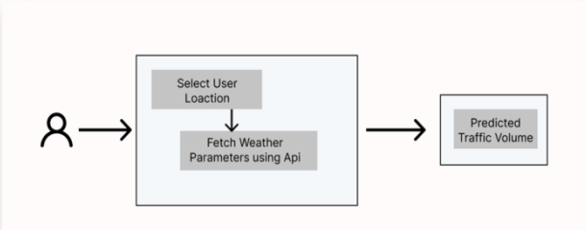

**Step-2: Brainstorm, Idea Listing and Grouping**

Now, the question arises of how to improve the capacitor y of the road network. To solve this *problem* the first solution that occurs to most of us is to build more highways, expanding the number of lanes on the road. However, according to the study done by scholars, expanding the road capacity will cause more serious traffic conditions.

This study aims to find a traffic volume predictor appropriate for practical applications. In terms of power consumption and computation cost, this predictor needs to be precise. In our pursuit of such a predictor, we have incorporated the following contributions: We compare existing schemes to seek out their effectiveness for real-time applications.

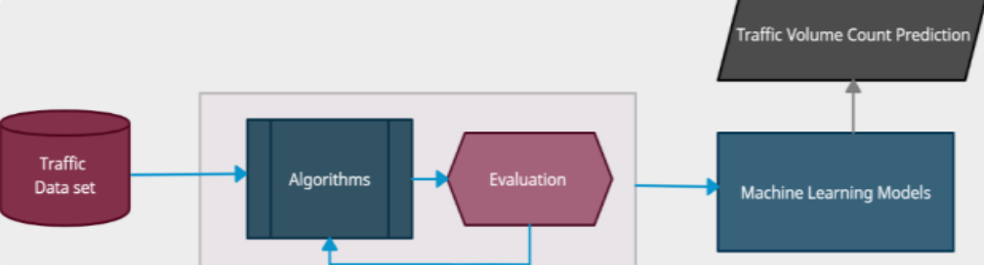

**Step-3: Idea Prioritization**

To make this existing system more efficient and enforce traffic environment for efficient and accurate transportation, which may help us better arrange transportation resources, disperse the traffic flow before it's overloaded, and even provide more abundant on-road entertainment. Where one such need arises towards the prediction of traffic volume count. Importance of traffic volume: • Better implies for advancement of infrastructures. • Provides way better implies to utilize streets • Accurate activity volume forecast can help course arranging, and relieve activity congestion. • All of these planning will also help the government and rest of bodies

